

**NATIONAL ECONOMIC CONSULTATIVE FORUM**

**MONTHLY ECONOMIC BULLETIN**

**30 SEPTEMBER 2024**

# Executive Summary

This bulletin focuses on economic developments for the month ending 30 September 2024 that include, World economic developments, international commodity prices, Zimbabwe Gross Domestic Product (GDP) growth updates, merchandise trade developments, exchange rate developments, inflation developments, monetary developments and stock market developments.

Global economic growth is projected to stabilize at a subdued 2.7% in both 2024 and 2025, according to the United Nations, constrained by high interest rates, limited fiscal resources, and geopolitical tensions, particularly in the United States and the Middle East. Low-income countries, especially in Africa, face added challenges from tightening financial conditions, rising debt servicing costs, and climate change impacts. Southern Africa is expected to grow modestly at 1.8% in 2024, improving to 2.5% in 2025.

Global inflation trends indicate moderation, especially in developed economies where inflation approaches central bank targets. While inflation remains higher in developing economies, overall projections suggest gradual reduction in 2025, potentially easing imported inflation pressures on Zimbabwe’s economy.

Commodity prices exhibited mixed trends, with year-to-date increases in natural gas, aluminum, copper, nickel, and gold, while agricultural commodities like soybeans and wheat showed declines. Strong performance in metals, particularly gold, supports Zimbabwe's mining sector, but lower agricultural commodity prices challenge the agricultural sector.

Zimbabwe’s GDP growth is expected to stagnate at 2% in 2024, impacted by El Niño-induced drought, low mining prices, and macroeconomic instability, including power shortages and currency depreciation. Growth is anticipated to recover to 6.2% in 2025 as climate effects ease and investments enhance mining and manufacturing output.

Trade data shows a 7.9% increase in merchandise trade from June to July 2024, primarily driven by rising gold exports. However, the trade deficit widened due to increased maize imports addressing drought impacts.

In the parallel market, the USD/ZWG rate fluctuated from 23 to 40 in September 2024. The ZWG devaluation by the Reserve Bank on 27 September 2024, narrowed the premium between the official and parallel exchange rates, reducing the premium from 136% to 60% by the end of the month. This move helped stabilize the ZWG in the short term but underscored persistent currency instability within the economy.

In cross-rate developments, the USD weakened against key global currencies, including the GBP, EUR, and ZAR, by 1.69%, 0.82%, and 3.82%, respectively, on a monthly basis. This USD depreciation supports Zimbabwe’s export potential to South Africa, its largest trading partner in the region, providing a favorable outlook for exports to the South African market.

Inflation in Zimbabwe surged in September 2024, driven largely by ZWG devaluation, with food and utilities being primary inflation drivers. Monetary developments reveal a broad money increase in July 2024, yet low deposit rates dampen savings incentives, while high lending rates restrict borrowing. This environment fuels informal market activities and limits economic growth potential.

Zimbabwe’s stock exchanges reflected positive sentiment in September 2024, with gains across indices on both the Zimbabwe Stock Exchange (ZSE) and Victoria Falls Stock Exchange (VFEX). Despite these gains, value traded on both exchanges showed notable year-to-date declines, indicating cautious trading volumes amid ongoing economic challenges.

**Table of Contents**

Executive Summary i

List of Tables iv

List of Figures v

1.0 World Economic Developments 1

1.1 World Output 1

1.2 Global Inflation Developments 1

2.0 International Commodity Prices 2

3.0 Zimbabwe GDP Growth Update 2

4.0 Merchandise Trade Developments 3

5.0 Exchange Rate Developments 3

5.1 ZWG Exchange Rate Developments 3

5.2 Parallel Market Developments 4

5.3 Cross Rate Developments 4

6.0 Inflation Developments 5

7.0 Monetary Developments 6

7.1 Money Supply 6

7.2 Interest Rates 7

8.0 Stock Market Developments 8

8.1 Zimbabwe Stock Exchange 8

8.2 Victoria Falls Stock Exchange 8

9.0 Recommendations 9

10.0 References 11

# List of Tables

Table 1: Global Economic Growth Developments 1

Table 2: Commodity Price Movements – Month Ending 30 September 2024 2

Table 3: ZWG Exchange Rate Movements - Month Ending 30 September 2024 4

Table 4: USD Exchange Rate Movements – Month Ended 30 September 2024 5

Table 5: Monthly Inflation for September 2024 6

Table 6: Interest Rates as at 20 September 2024 7

Table 7: Zimbabwe Stock Exchange Movements 8

Table 8: Victoria Falls Stock Exchange Movements 9

# List of Figures

Figure 1: Merchandise Trade Developments 3

Figure 2 : Parallel Market Developments - September 2024 4

Figure 3: Month-on-Month ZWG Inflation Outturn 5

Figure 4: Month-on-Month Weighted Inflation Outturn 6

Figure 5: Broad Money (M3) Supply 7

# 1.0 World Economic Developments

## **1.1 World Output**

1.1.1 Global growth is projected to remain steady at 2.7% in both 2024 and 2025 (United Nations 2024) as shown in Table 1. Global economy is projected to be on a more stable trajectory however, growth remain subdued by high interest rates, limited fiscal space, fears of a sharper-than -expected slowdown of the US economy, escalating of war in the Middle East and ongoing geopolitical uncertainties continue to cloud economic prospects.

1.1.2 Moreover, a high number of low-income countries especially in Africa, continue to face weak growth due to tight financial conditions, rising debt service cost and ever-worsening impact of climate change.

Table 1: Global Economic Growth Developments

|  |  |  |  |  |  |
| --- | --- | --- | --- | --- | --- |
|  | **Actual** | **Projections** | | | |
| **2023** | **2024** | | **2025** | |
|  | **IMF** | **IMF** | **UN** | **IMF** | **UN** |
| **Global** | **3.3** | **3.2** | **2.7** | **3.3** | **2.7** |
| **Advanced Economies** | **1.7** | **1.7** | **1.7** | **1.8** | **1.6** |
| United States | 2.5 | 2.6 | 2.5 | 1.9 | 1.7 |
| Eurozone | 0.5 | 0.9 | 0.8 | 1.5 | 1.3 |
| **Developing Economies** | **4.4** | **4.3** | **4** | **4.3** | **4.2** |
| China | 5.2 | 5 | 4.8 | 4.5 | 4.5 |
| India | 8.2 | 7 | 6.9 | 6.5 | 6.6 |
| **Africa** |  |  | **3.3** |  | **3.9** |
| Southern Africa |  |  | 1.8 |  | 2.5 |
|  |  |  |  |  |  |

*Sources: IMF, WEO July 2024 Update and United Nations, World Economic Situation and Prospects (WESP), September 2024 Update*

1.1.3 In Southern Africa, a 1.8% growth rate is expected in 2024 and expected to pick up to 2.5% in 2025. The global and regional growth have a huge impact in shaping Zimbabwe economic growth prospects.

## **1.2 Global Inflation Developments**

1.2.1 According to the United Nations WESP September 2024 Update, in many developed countries, inflation is gradually approaching the respective central bank’s target rate and in developing economies, it has also fallen but generally remains higher than in developed economies.

1.2.2 Global inflation is forecasted to moderate further in 2025 despite the prevailing upside risks such as geopolitical tensions and extreme weather events which threaten to disrupt shipping routes, raising freight costs and exerting upward pressure on commodity prices. This is in tandem with IMF projections which see global inflation slowing down to 4.5% in 2025.

1.2.3 These global inflation projections are a boon for Zimbabwe being an import-reliant economy, as this has a positive effect on controlling imported inflation.

## **2.0 International Commodity Prices**

2.1 During the month under review, all selected commodities recorded an upward price trend (see Table 2).

2.2 On a year-to-date basis (YtD) basis, natural gas, aluminum, copper, nickel, and gold prices firmed while crude oil, cotton, soybeans, corn and wheat prices retreated.

2.3 On a year-on-year (YoY) basis, some of the selected commodity prices recorded price decline though aluminum, copper, gold and wheat prices gained. The price trend exhibited by minerals like gold, aluminum and copper are encouraging to the Country’s mining sector while YtD and YoY price movements of agricultural commodities are discouraging for the agricultural sector.

Table 2: Commodity Price Movements – Month Ending 30 September 2024

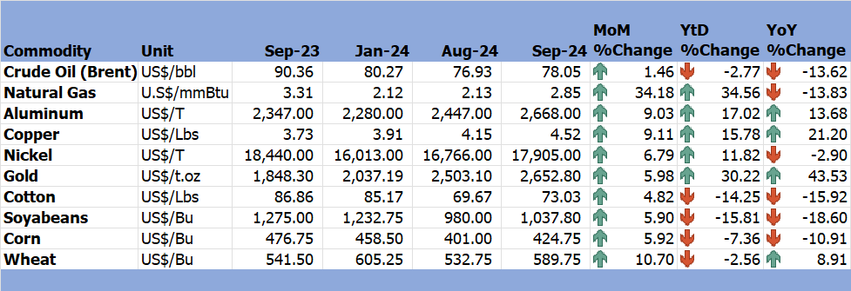

*Source: Trading Economics (2024)*

# 3.0 Zimbabwe GDP Growth Update

3.1 According to the World Bank (2024), Zimbabwe GDP growth is expected to remain at 2% in 2024 due to El-Nino induced drought, lower mining prices and macroeconomic instability. Agricultural production is expected to fall by over 20%, with ongoing power shortages contributing to decreased industrial growth and disrupted crops that depend on irrigation, while the rise in parallel market premium continues to limit formal sector production and demand thus bringing instability to the ZWG.

In terms of outlook, growth is projected to recover to 6.2% in 2025 once the effects of drought begin to wane and ongoing investment initiatives start to increase mining and manufacturing production (World Bank 2024).

# 4.0 Merchandise Trade Developments

4.1 Zimbabwe National Statistics Agency (ZimStat) had not published the merchandise trade data for September 2024 by the time of compiling this report, thus the analysis is based on July 2024 data.

4.2 In July 2024, total merchandise trade was USD1371.4 million, 7.9% higher than the USD1271.5 million recorded in June 2024 due to a rise in international trade activities. On a YoY basis, merchandise trade decreased by 1% from USD1385.5 million in July 2023 (RBZ July 2024 Monthly Review).

4.1 Trade deficit stood at USD274.8 million, which was higher than the USD218.9 million recorded in June 2024. This is mainly attributed importation of maize to curb impact of El-Nino drought. The import bill amounted to USD823.1 million in July 2024 reflecting a 10.2% increase from USD746.7 million recorded in June 2024. In July 2023, the import bill amounted to USD782.3 million. Exports stood at USD548.3 million in July 2024, a 4.5% increase from USD524.7 million in June 2024 due to rise in gold exports driven by increase increase in global demand of the yellow metal. (see Figure 1).

Figure 1: Merchandise Trade Developments

*Source: RBZ (2024)*

# 5.0 Exchange Rate Developments

## **5.1 ZWG Exchange Rate Developments**

5.1.1 In September 2024, the ZWG lost value against all major currencies as shown in Table 4. The ZWG lost against the USD, GBP, EUR and ZAR by 209.52%, 82.68%, 81.09% and 86.74% respectively. The ZWG also lost value against the USD, GBP, EUR and ZAR both on YtD and YoY (see Table 4). This was mainly driven by ZWG devaluation by the RBZ on the 27th of September 2024.

Table 3: ZWG Exchange Rate Movements - Month Ending 30 September 2024

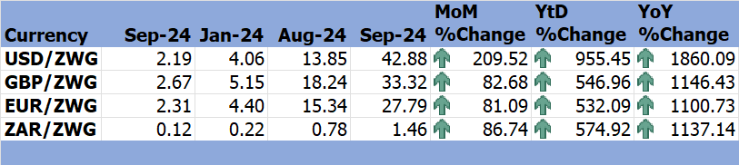

*Source: RBZ (2024)*

## **5.2 Parallel Market Developments**

5.2.1 During the month under review, parallel market rate fluctuated from USD/ZWG23 to USD/ZWG40 (see Figure 3). From the first of September 2024 to 26 September 2024, the official rate was lower and stable while parallel market was rising leading to rising exchange rate premium which inhibited convergence between the two exchange rates. Devaluation of the ZWG on 27 September 2024, reduced the gap between official exchange and parallel market leading to exchange rate premium falling from around 136% to 60% at the end of September 2024.

Figure 2 : Parallel Market Developments - September 2024

*Source: RBZ and Harare Streets (2024)*

## **5.3 Cross Rate Developments**

5.3.1 The USD lost value against the GBP, EUR and ZAR by 1.69%, 0.82% and 3.82 respectively, month-on-month (see Table 4). The USD also lost against GBP, EUR and ZAR on year-to-date and year-on-year. The USD movements are attributed to the November 2024 US elections and rising recession risks. The depreciation of the USD versus the ZAR boosts the country’s exports to South Africa.

Table 4: USD Exchange Rate Movements – Month Ended 30 September 2024

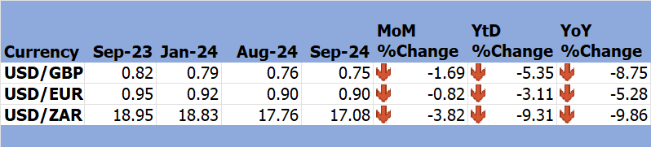

*Source: RBZ (2024)*

# 6.0 Inflation Developments

6.2 ZWG inflation rose from 1.4% in August 2024 up to 5.8% in September 2024 (more than tripled) see Figure 3. The sharp jump in ZWG inflation is attributed to the devaluation of the ZWG by the Reserve Bank of Zimbabwe of the 27th of September 2024 which eroded about 70% of the ZWG purchasing power.

Figure 3: Month-on-Month ZWG Inflation Outturn

*Source: ZimStat (2024)*

6.2 In September 2024, weighted inflation increased from 0.4% in August 2024 to 1.9% in September 2024 (see Figure 4).

Figure 4: Month-on-Month Weighted Inflation Outturn

*Source: ZimStat (2024)*

6.3 The main contributors to both weighted and ZWG inflation in September 2024 remain food and non-alcoholic beverages and housing, water, electricity, gas and other fuels with weights of 31.3 and 27.62 respectively (see Table 5).

Table 5: Monthly Inflation for September 2024

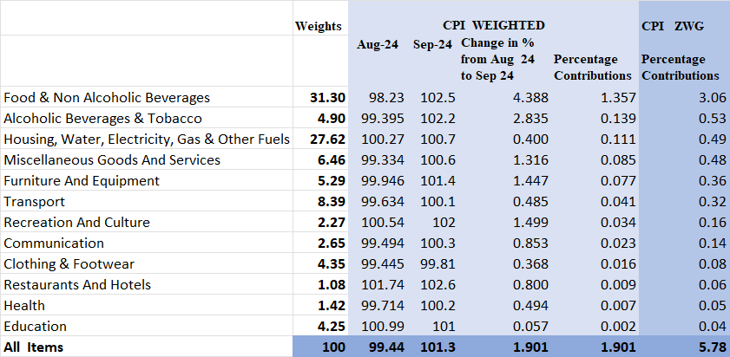

*Source: ZimStat (2024)*

# Monetary Developments

## **7.1 Money Supply**

7.1.1 Broad money stock stood at ZWG45.98 billion in July 2024, representing a 7.6% increase from the ZWG42.73 billion recorded in June 2024 (RBZ July 2024 Monthly Economic Review), while in July 2023, broad money supply stood at ZWG5.2 billion (see Figure 5). Broad money supply was comprised of 68.81% foreign currency transferable deposits, 0.13% currency in circulation, 0.04% NCDs, and 1.01% local currency time, 7.45% foreign currency time deposits and 22.56% local currency transferable.

Figure 5: Broad Money (M3) Supply

*Source: RBZ (2024)*

## **7.2 Interest Rates**

7.1.1 According to the RBZ September 2024 Weekly Economic Highlights, the average commercial bank deposit rates for savings remain unchanged ranging from 3.75% to 3.88% for ZWG while for foreign currency ranging from 1.53% to 1.86%. The commercial banks weighted lending rates for both individuals and corporates are shown in Table 6.

Table 6: Interest Rates as at 20 September 2024

|  |  |  |  |
| --- | --- | --- | --- |
| **Classification** | | **Minimum (%)** | **Maximum (%)** |
| Average Commercial Bank Deposit Rates | Local Currency | 3.75 | 3.88 |
| Foreign Currency | 1.53 | 1.86 |
| Commercial Banks Weighted Lending Rates (Forex) | Individuals | 10.85 | 14.93 |
| Corporates | 9.57 | 15.09 |
| Commercial Banks Weighted Lending Rates (ZWG) | Individuals | 24.31 | 30.45 |
| Corporates | 23.99 | 32.78 |

*Source: RBZ (2024)*

7.1.2 Low deposit rates for both local and foreign currency reduce the incentive to save thereby leading to reduced investment and circulation of money in the economy.

7.1.3 Higher lending rates for individuals compared to interest rates for corporates promotes borrowing for investment purposes than borrowing for consumption purposes. However, lending rates for both ZWG and Forex are restrictive since they translate to high cost of borrowing.

The combination of low deposit rates and high lending rates promotes informal money market, informal economy and reduced aggregate demand leading to suppressed economic growth. According to Davies *et al* (2022), high lending rates have negative impact on the economy especially with high inflation rate, they make it difficult to access loans, disadvantages customers and makes it difficult to service loans.

# 8.0 Stock Market Developments

## **8.1 Zimbabwe Stock Exchange**

8.1.2 In September 2024, ZSE recorded a bullish trend. All-Share Index, top 10 index, value traded, and market capitalization gained by 21.41%, 24.51% 268.98% and 21.68%, respectively.

8.1.3 On YtD and YoY, all selected indices gained except value traded losing by 51.96% on a YtD basis, see Table 7.

Table 7: Zimbabwe Stock Exchange Movements

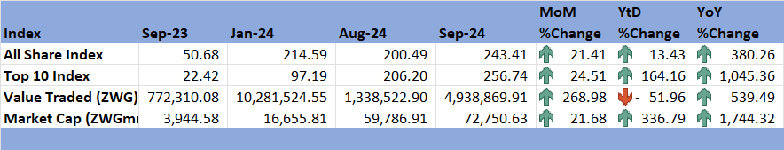

*Source: ZSE (2024)*

## **8.2 Victoria Falls Stock Exchange**

8.2.1 The VFEX market exhibited bullish sentiments in September 2024. All-Share index and market capitalization gained by 1.76% and 2.16% respectively, albeit value traded declining by 75.06% reflecting a USD123626.48 slowdown from August to September 2024 (see Table 8).

8.2.3 On YtD basis, All-Share Index and market capitalization gained while value traded lost 84.73%. All share index and value traded gained while market capitalization lost, on YoY basis.

Table 8: Victoria Falls Stock Exchange Movements

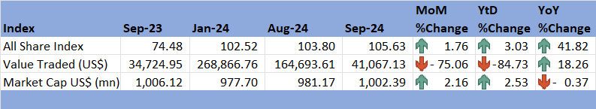

*Source: VFEX (2024)*

# 9.0 Recommendations

9.1 The following recommendations are being proposed:

9.1.1 **Improve Climate Change Preparedness Strategies**: The country should develop measures to reduce climate change such as investment in carbon sequestration, green infrastructure (smart cities), green finance, carbon credits, renewable energy and having national adaptation plan. These strategies reduce the effect of climate change on the country’s agriculture sector, the backbone of the economy.

9.1.2 **Mining Industry Enhancement**: Given the rising demand and prices of minerals like gold, copper and aluminium in the international market, the country should focus on enhancing value addition of its minerals exports. This increases the country’s export revenue.

9.1.3 **Exchange Rate Control**: The RBZ should let the exchange rate be determined on willing-buyer-willing-seller basis and prioritise on accumulating forex reserves and other special metal backing the ZWG for strategic interventions purpose. The willing-buyer-willing-seller basis will eliminate the parallel market players since. Exchange rate being price of forex like price of commodities, exchange rate stabilisation will translate to price stability hence reduced ZWG inflation in the Economy.

9.1.4 **Monetary Policy and Fiscal Policy realignment**: There is need for realignment of monetary and fiscal policies to promote fiscal discipline and policy consistency in the economy which will subsequently boost confidence, investment and economic growth.

9.1.5 **Interest Rate Policy Adjustment**: The low deposit interest rates discourage savings, while high lending rates limit borrowing for investment. Introducing incentives for savings accounts or lowering lending rates could stimulate investment in productive sectors, improving economic growth prospects without exacerbating inflationary pressures.

9.1.6 **Support Trade Growth by Addressing Trade Deficits:** With an increased trade deficit in July 2024, targeted trade policies to increase exports and manage imports are critical. Expanding export-focused support for sectors with high foreign demand, like mining, and reducing reliance on imports, especially for staple goods, could narrow the deficit and support Zimbabwe’s balance of payments.

9.1.7 **Stock Market Development**: There is need to upgrade trade infrastructure through investing modern trading systems and technologies on ZSE and VFEX. To promote participation, ZSE and VFEX must increase investor education and awareness to increase financial literacy to current and potential investors.

# 10.0 References

Davies, J. T. (2022). The Effects of High Lending Interest rates on SMEs in Sierra Leone: A Glance at Lenders' Perspectives. *American Journal of economics*, Vol 12(1) 20-29.

RBZ. (2024). *Exchange Rates*. Retrieved from Reserve Bank of Zimbabwe: https://www.rbz.co.zw/index.php/research/markets/exchange-rates

Reserve Bank of Zimbabwe. (2024). *Monthly Economic Review: June 2024.* RBZ.

Reserve Bank of Zimbabwe. (2024). *Weekly Economic Highlights. Vol. 26 No. 33.* RBZ.

Trading Economics. (2024). *Commodities*. Retrieved from Trading Economics: https://tradingeconomics.com/commodity/crude-oil

UN. (2024). *World Economic Situation and Prospects, September 2024.* United Nations.

VFEX. (2024). *Main Dashboard*. Retrieved from Victoria Falls Stock Exchange: https://www.vfex.exchange/

W. (2024). *W.* Retrieved from https://thedocs.worldbank.org/en/doc/bae48ff2fefc5a869546775b3f010735-0500062021/related/mpo-zwe.pdf

WEF. (2024). *Chief Economist Outlook September 2024.* World Economic Forum.

World Bank. (2024). *MPO Zimbabwe*. Retrieved from World Bank: https://thedocs.worldbank.org/en/doc/bae48ff2fefc5a869546775b3f010735-0500062021/related/mpo-zwe.pdf

ZimStat. (2024). *Inflation Rates*. Retrieved from Zimbabwe Statistics Agency: https://www.zimstat.co.zw/

ZSE. (2024). *Main Dashboard*. Retrieved from Zimbabwe Stock Exchange: https://www.zse.co.zw/

**NECF Secretariat, 2024**